Lab 9
Binary Search Tree

Objective:
The objective of this experiment is to implement a Binary Search Tree to be used for search applications.

Introduction:
A binary search tree satisfies the following conditions:
  - It is a binary tree
  - Every element in it has a unique key
  - The keys in a nonempty left subtree (right subtree) are smaller (larger) than the key in the root of subtree
  - The left and right subtrees are also binary search trees

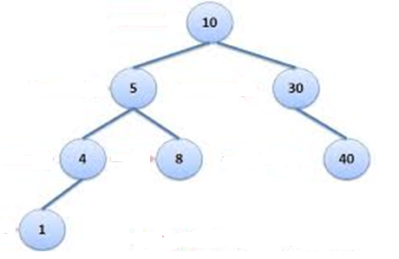

Exercise 1:
Using the Binary tree node class that you implemented in Lab7, implement part1 to part4 given in the Binary Search Tree class definition given as follows (you may name it as BinarySearchTree.h).

#ifndef BINARY_SEARCH_TREE_H
#define BINARY_SEARCH_TREE_H

#include "BNode.h"
using namespace std;

template<class DType>
class BinarySearchTree
{
public:
//part1: constructor
BinarySearchTree();

//part2: Create and insert a BNode carrying data
//in the binary search tree. It return true if
//insertion takes place successfully and false otherwise
bool insert(const DType data);

//part3: Search for data in the binary search tree
// and return the pointer of the node carrying data
//return null/0 if data doesn’t exist
BNode<DType> * search(const DType data);

//part4: prints all the data present in the tree
//sorted in ascending order
void printSorted();

//part5: delete the BNode carrying data from the
//binary search tree. It return true if
//deletion takes place successfully and false otherwise
bool delete(const DType data);

//part6: destructor, delete all nodes
~BinarySearchTree();

private:
BNode<DType> * root;

};
#endif
You may test your code using the following client
//Following is a sample client
#include<iostream>
#include "BinarySearchTree.h"
using namespace std;
int main()
{
//creating an object of binary search tree
BinarySearchTree<int> *BST=new BinaryTree<int>();

//following insertions should happen successfully as we are inserting unique values
BST->insert(12);
BST->insert(4);
BST->insert(9);
BST->insert(2);
BST->insert(14);
BST->insert(16);
BST->insert(13);

//this insertion should fail as 12 already exists in the Binary Search tree
BST->insert(12);

//prints data carried by the BST in sorted manner
BST->printSorted();

//the first search would be successful and second would fail
BNode<int>*n =BST->search(12);
If(n)
{
cout<<”Value exists”<<endl;
}
else
{
cout<<”Value does not exist”<<endl;
}

BNode<int>*n =BST->search(23);
If(n)
{
cout<<”Value exists”<<endl;
}
else
{
cout<<”Value does not exist”<<endl;
}

return 0;
}

POST LAB:
Implement part5 and part6 given in the Binary Search Tree class definition given in Exercise1. You may test it using the following client:

//Following is a sample client
#include<iostream>
#include "BinarySearchTree.h"
using namespace std;
int main()
{
//creating an object of binary search tree
BinarySearchTree<int> *BST=new BinaryTree<int>();

//following insertions should happen successfully as we are inserting
//unique values
BST->insert(12);
BST->insert(4);
BST->insert(9);
BST->insert(2);
BST->insert(14);
BST->insert(16);
BST->insert(13);
BST->insert(1);

//prints data carried by the BST in sorted manner
BST->printSorted();

//deleting leaf node
If(BST->delete(16))
{
cout<<”node carrying 16 deleted successfully”<<endl;
}
//deleting degree 1 node
If(BST->delete(2))
{
cout<<”node carrying 2 deleted successfully”<<endl;
}
//deleting degree 2 node
If(BST->delete(12))
{
cout<<”node carrying 12 deleted successfully”<<endl;
}
//prints data carried by the BST in sorted manner
BST->printSorted();

//destructor called
delete BST;

return 0;

}

